SCOPING EFFORT REPORT
Products / Project Name: D4/D5 Interface

Date: 12/08/2009

Version/ Document Number: 1

Author(s): Larry Yu
SCOPING EFFORT REPORT 1
REVISION HISTORY 3
TERMS AND DEFINITIONS 4
CHAPTER 1: PRODUCT MAKEUP 5
PROBLEM BEING SOLVED 5
REQUIREMENTS 6
FEATURES BEING BUILT 7
HIGH LEVEL 7
LOW LEVEL 8
OTHER BENEFITS 14
UNIT TEST CASES 14
ARCHITECTURE CONSIDERATIONS 15
The spec enabled Axiom to support NGOD D4 and D5 interfaces. This is considered an architecture change. Changes are discussed from following aspects. 15
RELIABILITY 15
SCALABILITY 15
COMPATABILITY 15
ENVIRONMENT 15
CONFIGURATION 15
PERFORMANCE 17
MONITORING 17
FUNCTIONAL CHANGES 17
REFERENCE DOCUMENTS 18
CHAPTER 2: SCOPE 19
EFFORT 19
DEPENDENCIES 19
RESOURCES 20
MILESTONES 20
CHAPTER 3: ISSUES, RISKS, AND PENDING DECISIONS 21
Appendix A VREP MESSAGE DEFINITION 23
HEADER 23
OPEN 23
KEEPALIVE 25
UPDATE 26
NOTIFICATION 31
APPENDIX B VREP PROTOCOL 33

REVISION HISTORY
DATE | VERSION | AUTHOR | REASON FOR UPDATE
8/7/09 | 0.1 | LYU | Initial Document
8/27/09 | 0.2 | LYU | Clarify project requirements, revise project scoping.
10/21/09 | 0.3 | LYU | Add Architecture and Functional descriptions
11/04/09 | 0.4 | LYU | Add VrepLib registry configuration options
11/05/09 | 0.5 | LYU | Add default D5 port
11/11/09 | 0.6 | LYU | Add more config option
12/08 | 1 | LYU | Update IPS and VMCA design spec

TERMS AND DEFINITIONS

LS | Location Server, A logical component with knowledge of the gateways (resources) in the system.
APM | Asset Propagation Server
NGOD | Next Generation On Demand
ODRM | On Demand Resource Manager
ODRMR | On Demand Resource Manager Router
SOP | Streaming Output Port
SOPG | SOP Group
TSID | Transportation Stream Identifier
VREP | Video Registration Protocol

PROBLEM BEING SOLVED

CHAPTER 1: PRODUCT MAKEUP
COX requests Axiom to balance Streaming Server (SS) bandwidth usage between streaming and propagation, so that the streaming and propagation/ingest requests can be better coordinated.

For example, if one NGOD SS instance is down in a logical cluster with multiple SS, Axiom needs to recognize that total streaming bandwidth is reduced. Current DNP configuration based solution could not handle this. When existing write bandwidth is not enough on target SS, IPS should not schedule more ingest to this SS until write bandwidth is available.

Service Discovery & Registration Interface is defined in NGOD architecture, which provides interface to manage streaming resources. The interface between SS and APM is D4 interface. The interface between SS and ODRM is D5 interface. The following shows all Service Discovery & Registration Interfaces:
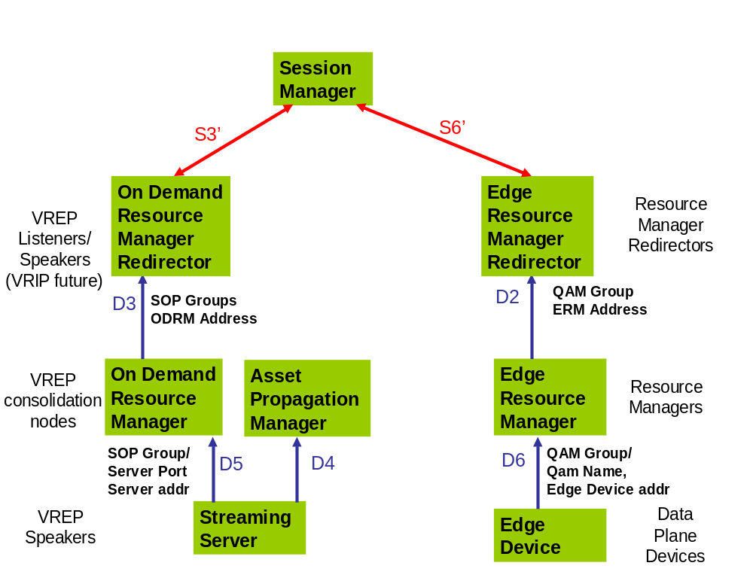

This document is to scope out efforts to implement D4 and D5 interfaces in Axiom.

REQUIREMENTS
D4/D5 support is targeted for Axiom 5.6 release. It is meant to address one particular issue for Axiom in NGOD environment: balance bandwidth usage between streaming and propagation/ingest operations.

Requirements for D4/D5 support in Axiom 5.6:
- Axiom must support VREP protocol. That includes VREP messages and VREP connect management. NGOD D4 and D5 interfaces are implemented on top of VREP protocol.
- VMCA must act as VREP listener to receive VREP message over D5 interface.
- VMCA must use total available bandwidth and volume’ available reading bandwidth during stream creation, which are reported through D5 interface,.
- VMCA must report following attributes to ICM: Total Bandwidth, Total Available Bandwidth, Volume’s read and write bandwidth and Service Status information collected through D5 interface.
- IPS service must act as VREP listener to receive VREP messages over D4 interface.
- IPS must schedule propagation jobs according to current available read/write bandwidth. When read or write bandwidth is not enough, IPS shall postpone that job. SS volume read/write bandwidth is reported through D4 interface.

Features are not considered in Axiom 5.6:
- New NGOD SS registration through D4/D5 interface. To add new NGOD SS, DNP configuration is still required. Then, VMCA needs restart to pick up new configuration.
- Streaming route selection using Reachable Route reported through D5 interface. In current implementation, Reachable Routes are ignored.

FEATURES BEING BUILT
A summary on components to build or modify:
- Extend Protlib library to add VREP protocol support. Leverage socket class defined in classlib library.
- Add new VrepLib library. Manage VREP connections using MSME state machine.
- Add interface to VrepLib to retrieve or update resource attributes.
- Modify IPS and VMCA services to implement D4 and D5 interface using VrepLib libraries.
- Create VREP speaker emulator to test IPS and VMCA implementation.

HIGH LEVEL
VREP protocol implementation is the key element for Axiom to support D4 and D5 interfaces. Once VREP protocol library is implemented, ITV services can use VREP protocol library to collect information through D4 or D5 interface.

VREP is TCP/IP based protocol. VREP can leverage existing infrastructure in ProtoLib library. ProtoLib library already contains a set of TCP/IP based protocols such as DSMCC, RTSP, HTTP etc. VREP can be implemented similarly.

VREP protocol is session based. MSME library can be used to implement VREP protocol session state management. To separate VREP session state management from its protocol message details, VREP session state machine must be implemented in a new library: VrepLib.

VrepLib shall implement license verification. It checks for license on using D4 or D5 NGOD interface. That is required by all NGOD components. Licensing is enforce at VrepLib level.

VMCA service talks to SS through D5 interface. It acts as VREP listener.

VMCA reads pre-configured NGOD cluster information out of DNP table during start up. VMCA does not handle DNP configuration changed event. It requires restart to pick up changes made in DNP configuration. That is VMCA’s existing behavior.

SS is provisioned with VREP listener address and port (VMCA VREP address and port). Once SS is up and running, its VREP speaker shall initiate connection with VMCA VREP listener. After connection is established, SS shall start sending VREP messages to report SS attributes.

When VREP connection is disconnected on error, it is SS’ responsibility to establish the connection again. VMCA VREP listener stays in listening state.

On receiving of VREP attributes through D5 interface, VMCA shall update pre-configured bandwidth values. The following information is interested by VMCA service:
- Available read/write bandwidth for associated volume.
- SS service status.
- Total bandwidth and total available bandwidth for streaming.

Once VMCA has bandwidth information available, it shall report them to ICM services.

IPS service talks to SS through D4 interface. It acts as VREP listener.

IPS gets store set information in two ways: 1) static configuration in registry; 2) dynamic configuration from ICM. In either case, IPS uses volume name (store ID) to identify each SS in store set configuration.

SS is provisioned with VREP listener address and port (IPS VREP address and port). Once SS is up and running, its VREP speaker shall initiate connection with IPS VREP listener. After connection is established, SS shall start sending VREP messages to report SS attributes.

When VREP connection is disconnected on error, it is SS’ responsibility to establish the connection again. IPS VREP listener stays in listening state.

On receiving of VREP message update, IPS shall collect the following information:
- Volume name.
- Volume available read and write bandwidth

IPS uses volume name to link available bandwidth information to IPS stores in store set. Then, IPS updates store with available read and write bandwidth and uses that to schedule propagation tasks.

When IPS schedules propagation job, it shall look at source SS’ available bandwidth and target SS’ writing bandwidth. If both have enough bandwidth, IPS will schedule the job. Otherwise, postpone the job.

LOW LEVEL
VREP protocol
ProtLib
Define types to manage messages of VREP protocol. Refer to Appendix A in this document for VREP message definitions.

Implementation details on VREP messages:
- Define classes for each of VREP messages: OPEN, UPDATE, NOTIFICATION, KEEPALIVE.
- Add a parser to encode or decode VREP messages to and from a byte buffer. Parser shall handle byte re-ordering to allow non-windows client.
- Add vrep_channel and vrep_channelmgr class to manage socket connections between VREP listener and speaker.
- Add vrep_sniffer utilities to log VREP messages.

A summary of D4/D5 attributes in UPDATE message.
Resource Attributes  (Type Code) | Requires by D4/D5 interface | Descriptions
Withdrawn Route (1) | Must | Set of routes being withdrawn from service.
Reachable Route (2) | Must | Set of routes to be added to service.  Routes are configured through Nx interface.  A route specifies the transport network from SS to QAM.  Route name for SS is SOP Group Name
NextHopServer  (3) | Must | It is associated with the Reachable Route attribute.  SS interface address to send control command. It is either R2 or A3.
Total Bandwidth  (234) | Must (for D5) | It is associated with the Reachable Route attribute.  It indicates the total amount of bandwidth capable of being transmitted and/or received to/from the network (in kbps) for reported output port in the Reachable Route.  The streaming bandwidth for reported route.
Available Bandwidth  (235) | May | It is associated with the Reachable Route attribute.  It indicates average amount of bandwidth available over a given period of time (computed by calculating a running average of total bandwidth minus bandwidth in use).  The averaging period is approximately 30 minutes.
Cost  (236) | Should | Relative cost associated with the resources from a resource manager.  It is used in resource manager selection: a lower value of cost is preferred.
Volume  (240) | Must | Represents input to a SS. It has no relationship with route. It contains available read and write bandwidth of the volume (in kbps)  It is sent after a connection is established and when the value changes.  An update should be sent to VREP listener whenever the BW changes exceed the pre-configured number in SS.  For example, if the number of streams from a volume increase, which causes the server to decrease the amount of BW the server can use to write to the volume, the streaming server should send an UPDATE to the APM. Likewise, write bandwidth may reduce the amount streams a streaming server can serve from a volume. In this case the Streaming server should send an update to the ODRM.
Service Status  (241) | Should | It is not associated with a Reachable Route attribute.  Operational state of the component – the output port status (SOP)  (running, shutting down or standby).
Max MPEG Flows  (242) | May | It is associated with the Output Port.  Max number of MPEG flows a recource can contain.
Next Hop Alternatives  (243) | May | Alternate of the NetxHopServer
Output Port  (244) | Must (for D5) | It is associated with Reachable Route attribute.  Specifies the output port ID to which a SOP is associated. It is unique only within SS.  SOP could be logical, the same for Port ID.
Output Address  (245) | Must (for D5) | It is associated with Reachable Route attribute.  Specifies the IP address of the output from a SS.
Transfer Protocol Capabilities  (246) | Must (for D4) | Supported transfer protocol (FTP, PGM, NFS or CIFS)

VrepLib
Create state machine to manage VREP connection states. It uses VREP types and socket types defined in ProtoLib to manage VREP connection. Refer to Appendix B section for connection state changes.

States for a VREP connection session:
- Idle
- Connect
- Active
- OpenSent
- OpenConfirmed
- Established

Events to change VREP connection state:
- Start event, it transfers local VREP from Idle to Connect state.
- Incoming TCP connection event, it transfers local VREP to OpenSent state.
- TCP connection failure event, it transfers local VREP to Active state.
- Connect state ConnectRetry timer off event, local VREP stays in Connect state.
- Active state ConnectRetry timer off event, it transfers local VREP from Active to Connect state.
- OPEN msg error event, it transfers local VREP from OpenSent to Idle state.
- OpenSent state sends KEEPALIVE msg event, it transfers local VREP from OpenSent to OpenConfirmed state.
- Hold timer off event, it transfers local VREP from OpenSent to Idle state.
- Disconnect event, it transfers local VREP to Active state.
- Stop event, it transfers local VREP to Idle state.
- OpenConfirmed state KEEPALIVE received event, it transfers local VREP from OpenConfirmed to Established state.
- OpenConfirmed state received NOTIFICATION msg event, it transfers local VREP from OpenConfirmed to Idle state.
- NOTIFICATION msg event, it transfers local VREP to Idle state.

VrepLib shall read registry for configuration options during initialization. Its registry hive is a sub-key under parent service (Vrep). Refer to Architecture Consideration’s Configuration section on registry details.

Provide interface to start/stop VREP speaker or listener. After NGOD license verified and VrepLib initialized, the start method shall put local VREP in Idle state and start a timer to generate Start event. The Stop method shall put local VREP in Idle state regardless what state it was in. A VREP NOTIFICATION message shall be sent to connected peers.

If NGOD license verification failed, VrepLib shall not initialize itself and log information into log file and event log. To verify license, VrepLib calls license validation routine from ScLicense library.

Refer to “License Management Installation and Configuration Guide” document for more on how licensing works in Axiom.

The state machine shall manage local VREP connections and process VREP messages.

Since NextHopServer attribute may not be included in every VREP messages, VrepLib shall cache received VREP attributes and report them to parent service when NextHopServer attribute is available. Attributes are cached in each VREP connection session. Only the latest attribute values are cached.

The Reachable Route and Withdrawn Route attributes modify total bandwidth for given SS. It adds or removes Output Port (SOP) and its associated bandwidth value from SS’ route table. To report bandwidth to parent service, VrepLib shall report each available SOP and its bandwidth instead of the aggregated bandwidth for the SS.

VrepLib provides a callback interface to notify attributes to parent service. Parent service shall subscribe to that callback. Callback functions are invoked whenever new message received and attribute value changed.

Provide ManUtil report interface to report VREP resource attributes collected.
- VREP configuration options report
- VREP Attributes report

Add log utility using Clog library following logging implementation patterns in other Axiom libraries.

A .NET wrapper VrepLibNet is required to export VrepLib to .NET application. IPS service is .NET application. VrepLibNet shall provide methods to start/stop VREP listener as well as methods to retrieve VREP attributes.

VMCA
Add a registry option to enable D5 interface support in VMCA. When that option is set, VMCA shall start VREP listener to support D5 interface and update NGOD cluster with information collected through D5 interface. If no D5 information is available, the default value from DNP is used. If that registry option is off, VMCA does not support D5 interface.

Modify VMCA startup process (VirtualMCAApplication::OnStartService() method) to initialize VrepLib. It shall conditionally initialize VrepLib based on VrepEnabled registry setting.

Add VREP class to interact with VrepLib library. It must initialize and terminate VrepLib library. VREP listener gets started during application initialization.

Implement a VrepLib call back function in VREP class. Register this callback function to VrepLib. It shall receive SS attributes such as Total Bandwidth etc. The callback function shall look up the main state machine for virtual cluster and update its bandwidth information as well as the operation status.

Identifier to link received NGOD SS attributes with VMCA virtual clusters
Since VMCA still starts with DNP configuration, an identity in requires to link received SS attributes to the virtual NGOD cluster. That link is the R2 interface URL and port, which is reported as Next Hop Server attribute through D5 interface.

Total Bandwidth and Total Available Bandwidth
They specify network output capability of SS. Based on the D5 spec, reported Total Bandwidth is associated with the reported Reachable Route including output address and port in that UPDATE message. Each output port is mapping to a spigot object. Loop through spigot objects managed by virtual cluster and update their bandwidth information. To get cluster’s total bandwidth, add total bandwidth of all spigots in that SS. Spigots are managed by VMCA virtual node (node is managed by VNSM state machine).

In VMCA, VNSM currently supports GET_PARAMETER over R2 interface for SOP port bandwidth update. That implements BroadBus specific feature. Then, the collected total bandwidth is sent to ICM service. That provides the bandwidth report infrastructure to re-use. To report Total Bandwidth collected from D5 interface, VMCA shall use similar logic implemented in VNSM::SetPortBandwidth() method.

Volume available read-write bandwidth
Volume specifies input capability of SS. Its available read-write bandwidth specifies the capability SS reads from or writes to the storage volume.
Read-write bandwidth maps to virtual NGOD node’s read and write bandwidth. It shall be reported the same as Total Bandwidth.

Service status
Service status is for the NGOD component. For D4 and D5 interfaces, that is the SS operation status. VMCA shall report it to ICM along with bandwidth information.

VMCA currently has ways to get SS status. Service status received over D5 overwrites status retrieved using existing method. On receive of service status, VMCA shall report SS status as following:
- Standby: NGOD spec explains that standby status indicates a redundant device to replace a failed device and the fail over details is for future study. VMCA shall handle standby as shutting-down, which means ICM will not use that SS for streaming. VMCA shall report SS down.
- Shutting Down: SS is gracefully shut down. All Reachable Routes and associated bandwidth shall be removed for this SS. VMCA shall report SS down.
- Operational: SS is up and running. VMCA shall report SS up.

If D5 connection is lost, VMCA shall wait for a period of time (using start event timer and connection retry timer as reference) and see if D5 connection is reconnected. If no connect established after that timer expired, VMCA shall report SS down if D5 is the only way to get SS status. Currently, VMCA has other ways to get SS status, so, it shall fall back to that.

Reachable Routes and Withdrawn Routes
Reachable routes report how SOP is connected to the delivery network. Each route has associated SOPs. Withdrawn Route is to take a Reachable Route out of the delivery network. That includes the associated SOPs.
On receive of the Withdrawn Route, VMCA must update related spigot state so ICM removes them from streaming route selection list.
VNSM::SetPortState() method is the place to integrate D5 SOP state.

IPS service
Add a registry option to configure IPS for D4 interface support. If that option is on, IPS shall initialize VrepLibNet during startup and start a VREP listener.

Implementation details in IPS will be provided by engineer from IPS team later. This document only specifies the VrepLibNet and the interface on that library. IPS team will take over the integration work.

Connection between VREP attributes and IPS store:
The Volume attribute reports the volume name over D4 interface. IPS shall use that to link received SS attributes to configured NGOD stores. IPS’ stores information are obtained from either ICM or registry.

Volume available read-write bandwidth
To schedule propagation task, IPS validates reading bandwidth is enough from source cluster and writing bandwidth is enough on the target cluster.
To start point to point ingest, IPS validates target store’s writing bandwidth for that ingest. IPS handles MCD ingest the same way: validate there is enough writing bandwidth for MCD ingest job.
If bandwidth information is not received for a NGOD cluster, IPS default available read/write bandwidth to 0.

VREP speaker emulator
Create a VREP speaker using VrepLib. It acts as a test utility while developing D4/D5 support.

On start of emulator, it tries to make VREP connection with given VREP listener address and port. Once VREP connect is established, it shall send periodic UPDATE message with varies bandwidth information.

OTHER BENEFITS

UNIT TEST CASES
1, OPEN message
Test VREP message parser with OPEN message
Create an OPEN message, use parser to encode then decode it.
Compare decoded OPEN message to the original one. Make sure all fields are decoded correctly.

2, NOTIFICATION message
Test VREP message parser with NOTIFICATION message.
Create NOTIFICATION messages with different error conditions. Encode then decode the message.
Compare decoded NOTIFICATION message to the original one. Make sure all fields are decoded correctly.

3, UPDATE message
Test VREP message parser with UPDATE message.
Create UPDATE messages with varies attributes. Encode then decode the message.
Compare decoded UPDATE message to original one. Make sure all fields are decoded correctly.

4, Message parser
Test VREP message parser with mal-formed VREP messages.
Create VREP messages with errors injected, such as parameter length etc.
Verify message parser returns with proper error indications.

5, Establish VREP connection
Test VREP connection
Create VREP listener and VREP speaker. Instruct speaker to connect with listener.
Verify connection can be established with given correct message sequence.

6, VREP error handling
Test VREP session error handling.
Use VREP listener and speaker created in previous test case.
Simulate different error conditions while establishing VREP connection.
Verify connection failed with proper NOTIFICATION message.

ARCHITECTURE CONSIDERATIONS

The spec enabled Axiom to support NGOD D4 and D5 interfaces. This is considered an architecture change. Changes are discussed from following aspects.

RELIABILITY
A new module, VREP Library, is added to manage VREP protocol. Extensive unit tests are required to guarantee the new component’s reliability.

VREP protocol is TCP/IP based. That makes sure the message delivery is reliable.

VREP connection is managed in Vrep Library. Disconnect of a VREP connection does not affect Axiom service’s reliability. Axiom service must react to connection disconnected event: either ignore it or consider Streaming Server is down. It depends on if the service still has access to Streaming Server’s control interface (A3 or R2).

VREP connection does not support dual rail. When connection lost, VREP speaker shall try to re-establish the connection per VREP spec.

SCALABILITY
Changes in this spec do not affect VMCA and IPS services’ scalability.

COMPATABILITY
The design is backward compatible for VMCA and IPS services. Between VMCA and SS, if D5 support is disabled, VMCA falls back to previous model and works without D5 information. Between IPS and SS, if D4 support is disabled, IPS falls back to previous model and works without D4 information.

If only one side enabled VREP support between Axiom and NGOD SS, VREP connection would never get established. Axiom services shall work like D5 or D4 interface is disabled.

ENVIRONMENT
No changes.

CONFIGURATION
New registry values are added to configure VREP listener for VMCA and IPS services. NGOD SS needs to be configured with VREP listener address.

New registry keys added for VMCA service:

HKEY_LOCAL_MACHINE\Software\SeaChange\ITV\CurrentVersion\Services\VMCA
HKEY_LOCAL_MACHINE\Software\SeaChange\ITV\CurrentVersion\Services\IPS\Fullfillment\XHFulfillment
Name | Type | Default | Description
VrepEnabled | REG_DWORD | 1 | Enable or disable VREP support in VMCA service.

A new sub-key is added under VMCA:

HKEY_LOCAL_MACHINE\Software\SeaChange\ITV\CurrentVersion\Services\VMCA\Vrep
Name | Type | Default | Description
HoldTimerSeconds | REG_DWORD | 240 | The initial hold timer in seconds for local VREP peer. If given time passed and local peer did not receive any VREP message, local peer will close the connection.
StartEventTimerSeconds | REG_DWORD | 60 | The initial start event timer value in seconds.
ConnectRetryTimerSeconds | REG_DWORD | 60 | The connection retry timer in seconds. On connection failure, VREP speaker will retry connection after specified time passed.
Capability | REG_DWORD | 3 | Specify local VREP listener’s send-receive capability.  The default is receive only.
ProtocolVersion | REG_DWORD | 1 | Specify locally supported highest VREP protocol version.  Currently, VREP protocol version is 1.
LogLevel | REG_DWORD | 2 | Indicate VrepLib library logging level.
LogFileMaxSize | REG_DWORD | 10000000 | Specify the log file limit. Log will wrap when hit that limit.
LogFileName | REG_SZ |  | Configure VrepLib library log file name.  This registry is optional. If it is not configured, VrepLib will create a log file under %ITVROOT%\log folder.  The default value is NULL string
LocalPort | REG_DWORD | 7051 | Specify local TCP port VREP listener listening on
LocalAddr | REG_SZ |  | Specify local address VREP listener listening on.  The default value is the server to server network address. The none-clustered address of Legato pair.
EnableProtocolSniffing | REG_DWORD | 0 | Indicate if VREP protocol message sniffing is enabled. Once enabled, all VREP messages are logged to VrepLib log file.
StreamingZone | REG_SZ |  | Configure the streaming zone name.  It must be configured, there is no default value.
VrepId | REG_DWORD |  | Configure VREP peer identifier.  The default value is LocalAddr address in DWORD representation.

The new registry values for IPS server are the same except LocalPort and LocalAddr:

HKEY_LOCAL_MACHINE\Software\SeaChange\ITV\CurrentVersion\Services\IPS\Fullfillment\XHFulfillment\Vrep
Name | Type | Default | Description
LocalPort | REG_DWORD | 7052 | Specify local TCP port VREP listener listening on
LocalAddr | REG_SZ |  | Specify local address VREP listener listening on.  The default value is the clustered server to server network address. The clustered address of Legato pair.

PERFORMANCE
No changes

MONITORING
ManUtil is the tool to monitor VMCA and IPS on their SS attributes received over D5/D4 interface.

FUNCTIONAL CHANGES
There are two Axiom services changed to support D4 and D5 interface: IPS and VMCA. This section is going to describe their functional changes.

NGOD D4 or D5 interface for IPS and VMCA are optional. If the feature is disabled, IPS and VMCA shall work as they used to. In other words, disabling D4 or D5 interface must not break IPS or VMCA.

Assume D4 and D5 interface support is enabled from this point on.

On service start, IPS and VMCA shall start a VREP listener to accept incoming VREP connections.

VMCA still reads configuration information from DNP database. But, it does not report virtual NGOD server operational until D5 connection is connected and reports service status as operational.

The DNP configuration shall match spigot to SOP reported over D5 interface. On receive of UPDATE message with bandwidth information, VMCA shall update bandwidth information on each spigot and the volume.

If a reachable route has been withdrawn, its associated SOP’s bandwidth (spigot) must be set to 0. No further streaming can be assigned to that spigot.

If D5 reports service status as Shutting Down, VMCA should reject any incoming streaming request and report status to ICM so that this virtual NGOD server does not get selected for any further streaming request.

VMCA handles Stand By status same as Shutting Down.

If D5 connection is lost, but the R2 interface is still accessible, VMCA shall still work properly. Otherwise, VMCA reacts to it similar to Shutting Down status. Once D5 connection re-established and R2 interface is accessible again, VMCA shall report that virtual server operational with bandwidth information.

IPS starts with all stores pre-configured. It completes initialization even D4 connection is not established yet. The available read/write bandwidth is 0 on initial start.

If D4 connection established, IPS starts to use read and write bandwidth of from reported NGOD volume to execute ingest/propagation tasks.

If D4 connection is lost but A3 interface is accessible, IPS continues to use read and write bandwidth for ingest/propagation tasks but adjust previous received bandwidth accordingly.

If D4 connection is lost and A3 interface is not accessible, IPS keeps retrying the tasks.

REFERENCE DOCUMENTS
NGOD Service Discovery specs - GEN_Service Discovery (NGOD 2.0).doc:
\\bedrock\projects\VOD\docs\Comcast\NextGenArch\V2.0\ NGOD 2.0 GENERAL Specifications.zip

SeaChange license manager document:
http://pubs.schange.com/index.php?mact=Uploads,cntnt01,getfile,0&cntnt01showtemplate=false&cntnt01upload_id=304&cntnt01returnid=255

EFFORT

CHAPTER 2: SCOPE

Engineering estimates:
Work item | Estimates
VREP protocol support: extend ProtoLib library. | 3 weeks
Unit test VREP protocol | 1 week
Create VrepLib part 1: manage VREP connections. | 2 weeks
Create VrepLib part 2: cache and manage attributes received from UPDATE message. Notify subscriber with received attribute values | 2 weeks
Unit test VrepLib | 1 week
Create .NET wrapper for VrepLib library | 1 week
Unit test VrepLibNet | 1 week
Modify VMCA to use VREP attributes | 2 weeks
Modify IPS to use VREP attributes | 2 weeks

SAQ estimates:
TBD

Documentation estimates:
Documents | Estimates
NGOD D5 interface scoping efforts.doc (new document) | 3 weeks

DEPENDENCIES
List all dependencies (both internal and external). Note that internal means Client Engineering, MediaCluster Engineering, etc. and external means SA, Motorola, DST, etc.

Unit test tool:
Use CPPUnit for c++ codes unit test. That includes VREP protocol and VrepLib.
Use NUint for managed code. That includes VrepLibNet.

RESOURCES

Engineer:
Larry Yu
Andrew Fournier
Govindaraaj Mudumbai
Vaishnavi Kondapalli
QA: TBD

MILESTONES

Milestones | Estimated completion time
Finish scope document for general review. | 8/28/2009
Complete VREP protocol implementation. Unit test OPEN, NOTIFICATION and UPDATE messages. | 9/28/2009
Complete VrepLib library development and unit test VREP connection management | 11/6/2009
Finish integration with VMCA and IPS services and test them with VREP speaker emulator. | 12/7/2009

CHAPTER 3: ISSUES, RISKS, AND PENDING DECISIONS
1, The solution has Dependency on CCUR’s D4/D5 implementation.
Based on requirements, Axiom’s implementation is to provide VREP listener to work with VREP speaker implemented by CONCURRENT streaming servers.

That means the success of final solution depends on how well Axiom works with CCUR’s video pump over D4 and D5 interface. To mitigate the risk, we should get CCUR’s implementation once it is available and start integration testing.

2, How should we model CONCURRENT pumps?
In DNP configuration, Axiom has have cluster, slice group and slice concept. The BW resources are reported at SOP level. D5 interface reports BW for given SOP port. SOP port name is used to configuring a slice in DNP table.

We consider a virtual NGOD cluster has unique R2 interface URI. That is the session management address while configuring nodegroup entry. Make sure all nodegroups in a virtual NGOD cluster have same session management address. With that, on receive of update message, iVMCA will be able to find which cluster to update by looking at the R2 interface URI.

Once virtual NGOD cluster is located, the SOP name is constructed in the format of “<SS name>.<Port ID>”. That name must be able to identify a unique slice by its port name in each node group. That slice is where the reported bandwidth goes.

3, Can Axiom have two VMCA instances work with one NGOD SS?
To eliminate single point of failure, Axiom could run two VMCA instances against one NGOD SS. Each VMCA manages a subset of the SS SOPs.
If SS can establish a D5 connections to each of those two VMCA nodes, how can VMCA interpret received BW numbers?
Total bandwidth is for SOP, on receive of UPDATE message, VMCA should find configured slice (mapped to SOP) and update its bandwidth. For those SOPs could not be found, they are managed by the other VMCA instance.

If VMCA reports those BW to ICM, should ICM add them together?
No, ICM should treat them as different cluster. Each nodes contains a subset of SOPs.

4, How to configure alternate listener IP address on SS?
It is possible to configure SS to talk to many VREP listeners. But, since VMCA service does not fail over to Propagation Network, current implementation does not consider that for VMCA. It is up to the SS to retry connection once disconnected.
For IPS, it does have fail over mode. The plan is to use clustered server to server address.

5, How often the Bandwidth update is going to be?
The concern is if that could cause IPS and VMCA performance issues.

6, How many VREP connections can VMCA or IPS handle?
The overhead of each VREP connection and message processing.

7, What does the received Total Bandwidth attribute describe?
Is it for the whole cluster or the specified SOP on the Reachable Route? The spec tends to explain it as the latter option. There are mandatory relationship among Reachable Route, Total Bandwidth, Output Port and Output Address attributes. That means the total bandwidth number is for the specified output port on given reachable route.
This aligns nicely with existing SS modeling: each output port (SOP) is modeled as a spigot. SOP’s bandwidth is reported as the corresponding spigot’s bandwidth.

8, MSME is complicated. It might be over-killing to apply it in VREP connection state management.

9, VrepLib might be used by projects outside Axiom.
Need to explore that possibility. The potential project in mind is uSRM.

10, VREP speaker emulator should be built in one of existing emulators, such as A3, ESM etc.

Appendix A VREP MESSAGE DEFINITION
VREP protocol contains 4 messages:
OPEN | Initiate a session between VREP speaker and listener.
UPDATE | Update VREP listener with SS information.
NOTIFICATION | For VREP listener or speaker to notify error.
KEEPALIVE | Detect resource manager failure in timely fashion

HEADER
Each message has a fixed-size header. It contains the following fields in given sequence:

Field | Size (Bytes) | Descriptions
Length | 2 | Unsigned short  Indicates total length of the message including the header.  The value of Length field must be at least 3.
Type | 1 | The type code of the message.  1 – OPEN  2 – UPDATE  3 – NOTIFICATION  4 – KEEPALIVE

OPEN
The first message sent out by each VREP peer is an OPEN message. If the OPEN message is acceptable, a KEEPALIVE message confirming the OPEN is sent back.

Field | Size (Bytes) | Descriptions
HEADER | 3 | Message header
Version | 1 | Indicates the protocol version. The current VREP version is 1.
Reserved | 1 | Reserved field
Hold Time | 2 | Unsigned short.  The number of seconds that the sender proposed for the value of the Hold Timer  On receive of OPEN message, local VREP must calculate Hold Time: using the smaller of its configured value and the Hold Time received. Hold Time must be either 0 or at least 3 seconds.
Reserved | 4 | Reserved field
VREP Identifier | 4 | Unsigned int  Indicates VREP Identifier of the sender. It must uniquely identify this sender within its Streaming Zone.  It is recommended that NGOD components set the VREP identifier to their IPv4 address when no identifier is configured.
Parameter Length | 2 | Unsigned short  Indicates total length of Parameters field in bytes.
Parameters | variable | May contain list of optional parameters encoded as <Parameter Type, Parameter Length, Parameter Value> triplet.

OPEN message parameters list
Field | Size (Bytes) | Descriptions
Parameter Type | 2 | Unsigned short  Indicates individual parameter type.  1 – Capability Information  2 – Streaming Zone  3 – Component Name  4 – Vendor Specific String
Parameter Length | 2 | Unsigned short  Length of Parameter Value field.  It is string length for:  Streaming Zone  Component Name  Vendor Specific String
Parameter Value | variable | Variable fields interpreted according to Parameter Type field  It is the string for:  Streaming Zone  Component Name  Vendor Specific String

Capability Information:
It is the value in Parameter Value field. It contains one or more <Capability Code, Capability Length, Capability Value> triplets.
Field | Size (Bytes) |  | Descriptions
Capability Code | 2 |  | Unsigned short  Identify individual capability.  1 – Route Types Supported  2 – Send Receive Capability
Capability Length | 2 |  | Unsigned short  The length of Capability Value field.
Capability Value | Route Type: 4 | Address Family: 2 | Route Types Supported Capability may contain multiple route types. It is only limited by max Capability Length field.  See Withdrawn Route attribute for definition.
Capability Value | Route Type: 4 | Application Protocol:  2
Capability Value | Or Send Receive Capability: 4 |  | Unsigned int  Indicates what mode the VREP sender will operate.  1 – Send Receive mode  2 – Send only mode  3 – Receive only mode  In phase 1 of NGOD, SS specifies send only mode; ODRMR specifies receive only mode.

Streaming Zone
Mandatory parameter. Parameter type code uses 2. It is the streaming zone the component operates in.

Component Name
Mandatory parameter. Parameter type code uses 3. It is the name of the component for data in UPDATE message. It is SS name for D4 and D5 interface.

Vendor Specific String
Parameter type code uses 4. It is anything SS vendor likes to put in.

KEEPALIVE
It is exchanged between peers so Hold Timer does not expire. It is 1/3 of Hold Time interval, but no more than once every 3 seconds. If negotiated Hold Time is 0, there is no KEEPALIVE message to be sent.
Field | Size (Bytes) | Descriptions
HEADER | 3 | KEEPALIVE message contains only HEADER structure. Its length is 3 bytes.

UPDATE
To transfer resource attributes (routing information) between VREP peers. In general, each UPDATE message contains the following fields:

Field | Size (Bytes) | Descriptions
HEADER | 3 | Message header.
First Route Attribute | variable | Resource attribute or Route information.
Second Route Attribute | variable | Resource attribute or Route information.
…

Each attribute is a <Attribute Type, Attribute Length, Attribute Value> triplet:
Field | Size (Bytes) | Descriptions
Attribute Type | 2 | Contains Attribute Flags byte followed by Attribute Type Code byte.  An attribute must appear in UPDATE message in numeric order of Attribute Type Code.  Attribute Flags:  Bit 0 – Well-Known Flag  The high-order bit (bit 0) of Attribute Flags byte if the Well-Known Bit. The other bits of Attribute Flags byte are unused. They must be zeroed on transmit and ignored on receive.  Currently, all attributes are Well Known.
Attribute Length | 2 | Unsigned short  The length of Attribute Value field.
Attribute Value | variable | Content depends on Attribute Flags and Attribute Type Code.

Attributes in UPDATE message:

Withdrawn Route attribute:
Flags: Well-Known
Type Code: 1
The syntax of withdrawn route:
Field | Size (Bytes) | Descriptions
Withdrawn Route 1 | variable
Withdrawn Route 2 | variable
Withdrawn Route 3 | variable

Format of each withdrawn route:
Field | Size (Bytes) | Descriptions
Address Family | 2 | Unsigned short  It gives the type of address for the route.  The following address family is defined:  32769 – NGOD name  32768-65535 are reserved for vendor specific application.
Application Protocol | 2 | Unsigned short  Specify NGOD interface and protocol used by that interface.  32771 A3 HTTP/XML SS  32772 R2 RTSP SS  32776 S3 RTSP ODRM  32768-65535 are reserved for NGOD applications.
Length | 2 | Unsigned short  The length of Address field.
Address | variable | The address of type specified by Address Family code.
Length | 2 | Unsigned short  The length of Route Name field
Route Name | variable | Test string for route name.  For SS and ODRM, route name is the SOP Group Name.

Reachable Route attribute:
Flags: Well-Known
Type Code: 2
It has same structure as Withdrawn Route attribute.

NextHopServer attribute:
Flags: Well-Known
Type Code: 3
It is mandatory if Reachable Route attribute is present. It specifies the address to use in order to control the resource in the reachable route. For D5, ODRM uses NextHopServer to connect for setting up streaming sessions; For D4, APM uses it to connect for controlling content propagation.
Field | Size (Bytes) | Descriptions
Reserved | 4 | Unsigned int  Should be set to 0.
Component Address Length | 2 | Unsigned short  The length of Component Address field
Component Address | variable | It contains the host name of IP address of the NextHopServer.  The name is defined as:  Name = host[“:”port]  Host = domain name, IPv4 or IPv6 address. IPv6 address must be enclosed in “[ ]”  Port = number  If port is not given, the default port for that service is assumed.
Streaming Zone Name Length | 2 | Unsigned short  The length of Streaming Zone Name field.
Streaming Zone Name | variable | ASCII string represents Streaming Zone the NextHopServer is associated with.

Total Bandwidth attribute:
Flags: Well-Known
Type Code: 234
It specifies total bandwidth controlled by a resource manager.

Field | Size (Bytes) | Descriptions
Total Bandwidth (kbps) | 4 | Unsigned int  Total network bandwidth

Available Bandwidth attribute:
Flags: Well-Known
Type Code: 235
It specifies the average bandwidth controlled by a resource manager over a period of time. It is computed by calculating a running average of the difference between the total bandwidth and the amount of bandwidth that is in use over the averaging period. In general, the averaging period is about 30 minutes.

Field | Size (Bytes) | Descriptions
Average Available Bandwidth (kbps) | 4 | Unsigned int  Average available bandwidth  Typically reported in 30 minutes period.

Cost attribute:
Flags: Well-Known
Type Code: 236
It represents the relative cost associated with the resource from a resource manager. A resource manager with a lower value of cost should be preferred over a resource manager with a higher cost.

Field | Size (Bytes) | Descriptions
Cost | 1 | Unsigned char

Volume attribute:
Flags: Well-Known
Type Code: 240
It represents the input to a streaming server and shows the storage volumes to which the streaming server attaches.
Field | Size (Bytes) | Descriptions
Volume Name Length | 2 | Unsigned short  The length of Volume Name field
Volume Name | variable | ASCII test string
Port ID | 4 | Unsigned int  The input port for SS. It is unique within the context of SS.
Available Read Bandwidth (kbps) | 4 | Unsigned int  Read bandwidth available.
Available Write Bandwidth (kbps) | 4 | Unsigned int  Write bandwidth available.
… repeat for another volume attached to SS.

Service Status attribute:
Flags: Well-Known
Type Code: 241
It specifies the operational state of SS.

Field | Size (Bytes) | Descriptions
Service Status | 4 | Unsigned int  Status code:  1 – Operational  2 – Shutting down  3 – Standby

Max MPEG Flows attribute:
Flags: Well-Known
Type Code: 242
It specifies the max number of mpeg flow supported by given resource.

Field | Size (Bytes) | Descriptions
Max MPEG Flows | 4 | Unsigned int

Next Hop Alternatives attribute:
Flags: Well-Known
Type Code: 243
When a SS consists more than 1 logical RTSP server where each logical RTSP server controls the sane set of SOP groups, Next Hop Alternatives attributes contain additional logical
Field | Size (Bytes) | Descriptions
Number of Alternates | 2 | Unsigned short  Number of alternate servers.
Length | 2 | Unsigned short  The length of Server Address field
Server Address | variable | It contains the host name or IP address.  The name is defined as:  Name = host[“:”port]  Host = domain name, IPv4 or IPv6 address. IPv6 address must be enclosed in “[ ]”  Port = number  If port is not given, the default port for that service is assumed.
… repeat until all alternate servers are included.

Output Port attribute:
Flags: Well-Known
Type Code: 244
It is mandatory when UPDATE contains reachable routes.
Field | Size (Bytes) | Descriptions
Port ID | 4 | Unsigned int  The output port to which a SOP is associated. It is unique within the SS.

Output Address attribute:
Flags: Well-Known
Type Code: 245
It specifies the output IP address of SS.
Field | Size (Bytes) | Descriptions
Address Length | 2 | Unsigned short  The length of Address field
Address | variable | IP address for the reachable route being updated by SS.  IPv6 address must enclosed with “[ ]”

Transfer Protocol Capabilities attribute:
Flags: Well-Known
Type Code: 246
It specifies which transfer protocol a SS can support.

Field | Size (Bytes) | Descriptions
Protocol Type | 1 | Unsigned char  It is combination of the following bitmask definitions.  Protocol Type definition:  0x01 – FTP  0x02 – NFS  0x04 – CIFS  0x08 – PGM

NOTIFICATION
When error condition is detected, a NOTIFICATION message is sent. NOTIFICATION message contains following fields:

Field | Size (Bytes) | Descriptions
HEADER | 3 | The message header.
Error Code | 1 | Unsigned char  The error code:  1 – Message Header Error  2 – OPEN Message Error  3 – UPDATE Message Error  4 – Hold Timer Expired  5 – Finite State Machine Error  6 – Cease
Error Subcode | 1 | Unsigned char  More specific information about the reported error.  Message Header Error Subcodes:  1 - Bad Message Length.  2 - Bad Message Type.  OPEN Message Error Subcodes:  1 - Unsupported Version Number.  2 - Bad Peer Address Domain.  3 - Bad VREP Identifier.  4 - Unsupported Optional Parameter.  5 - Unacceptable Hold Time.  6 - Unsupported Capability.  7 - Capability Mismatch.  UPDATE Message Error Subcodes:  1 - Malformed Attribute List.  2 - Unrecognized Well-known Attribute.  3 - Missing Well-known Mandatory Attribute.  4 - Attribute Flags Error.  5 - Attribute Length Error.  6 - Invalid Attribute.
Data | variable | The content depends on Error Code and Error Subcode.

APPENDIX B VREP PROTOCOL

In current implementation, a VREP session is initiated by VREP speaker (which is SS). Each VREP speaker is pre-configured with VREP listener information. That is done through Nx interface in NGOD architecture.

If a logical NGOD streaming server contains multiple physical servers, there is only one D5 connection out of that logical SS.

A message sequence chart to demonstrate how VREP listener and speaker interact with each other to establish a connection:
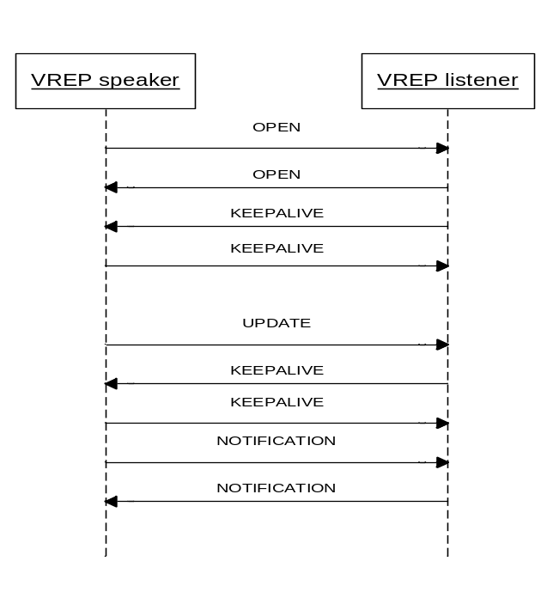

To walkthrough above VREP connection session message sequence:
While establishing a VREP session, OPEN message is the first message sent out for VREP speaker and listener. Then, the OPEN message is confirmed by KEEPALIVE message. After that, a VREP session is established.
UPDATE messages are sent from speaker with resource attributes. KEEPALIVE messages are sent in negotiated time interval to make sure VREP session is still alive.
When error happens, NOTIFICATION is sent to the remote peer and VREP session is torn down.

While trying to establish VREP session, the VREP session changes its state as following:
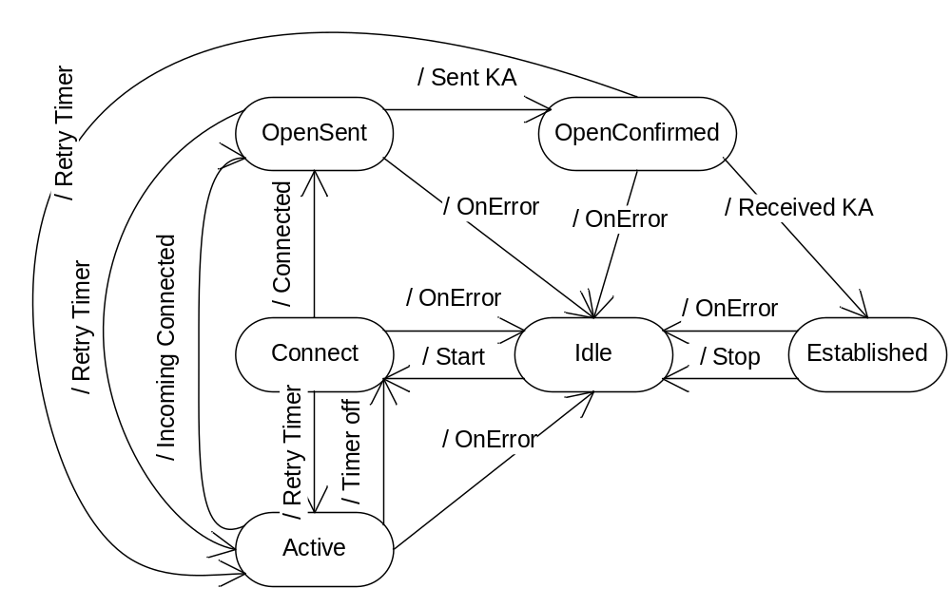
IDLE state:
When VREP speaker/listener (peer) first started, it is in Idle state which does not allocate any VREP resources.
A timer or similar mechanism to send Start event to VREP local when in Idle state.

CONNECT state:
Once received Start event, VREP peer initializes socket and speaker tries to connect to listener; the state changes to Connect. A ConnectRetry timer is started.
If ConnectRetry timer expired, VREP peer restarts ConnectRetry timer and stays in Connect state.

ACTIVE state:
If connection failed, VREP peer restarts ConnectRetry timer and changes to Active state. In Active state, VREP peer is listening for incoming connect only. It is not in the process of initiating a connection.
When ConnectRetry timer expires, VREP peer changes its state to Connect and initiates connection to VREP listener.

OPENSENT state:
Once TCP connection is established, VREP peer first sends OPEN message to negotiate VREP connection and changes state to OpenSent.
Local VREP clears ConnectRetry Timer then starts Hold Timer (4 minutes) and Keepalive Timer (1/3 of Hold Timer).
If session disconnected due to TCP error, the local VREP peer restarts ConnectRetry timer and changes to Active state.
If Hold Timer expired, it sends NOTIFICATION with error code “Hold Timer Expired” to its peer and change state to Idle.
If Stop event received, it sends NOTIFICATION with error code “Cease” to its peer and changes state to Idle.
On any other error, it sends NOTIFICATION with error code to its peer and change state to Idle.

OPENCONFIRMED state:
Once local VREP peer received OPEN message and sent a KEEPALIVE message to confirm it, it changes its state to OpenConfirmed.
Once Open message confirmed, adjust Hold Timer to negotiated value. If negotiated Hold Timer value is 0, it is not necessary to keep a peering session alive with Hold Timer.
If session disconnected due to TCP error, the local VREP peer restarts ConnectRetry timer and changes to Active state.
If received a NOTIFICATION message, it changes its state to Idle.
If Hold Timer expired, it sends NOTIFICATION with error code “Hold Timer Expired” to its peer and change state to Idle.
If Stop event received, it sends NOTIFICATION with error code “Cease” to its peer and changes state to Idle.
On any other error, it sends NOTIFICATION with error code to its peer and change state to Idle.

ESTABLISHED state:
Once local VREP received KEEPALIVE message for its OPEN message, it changes to Established state.
If received a NOTIFICATION message, it changes its state to Idle.
If Hold Timer expired, it sends NOTIFICATION with error code “Hold Timer Expired” to its peer and change state to Idle.
If Stop event received, it sends NOTIFICATION with error code “Cease” to its peer and changes state to Idle.
On any other error, it sends NOTIFICATION with error code to its peer and change state to Idle.

Hold Timer and KEEPALIVE timer
If Hold Timer expires, local VREP sends NOTIFICATION message and change state to idle. If local VREP receives an UPDATE or KEEPALIVE message, it restarts Hold Timer.
If KEEPALIVE timer expires, local VREP sends KEEPALIVE message and restarts KEEPALIVE timer. If local VREP sends an UPDATE or KEEPALIVE message, it restarts KEEPALIVE timer.
The suggested Hold Timer is 4 minutes to start with.

